Claire Willett
DS Final Project
08.15.13

Where is Waldo? Predicting Place on Twitter

That the internet homogenizes language is a matter of debate--but that it provides vast quantities of state-of-the-nation linguistic data is not. I was curious about linguistic diversity among American Twitter users--specifically, about whether that diversity, should it exist, could be regionally based. MacLuhan thought electronic communications would fashion a global village; I looked through one electronic communication to find if this was so.

Part 1: Getting and visualizing the raw data

There are a number of ways to grab public Twitter data. I chose the easiest way of all: using data someone else had already grabbed. In this case, these someones were a team of Compsci post-docs from Carnegie Mellon, led by Jacob Eisenstein. Over the course of analyzing lexical variation on Twitter, Eisenstein et al amassed a dataset tailor-made for my purpose. The data consists of a week's worth of tweets from users who lived within the 48 contiguous states, had less than 1,000 followers, and had posted at least 20 times over that week--that is to say ordinary, frequent users of the service.

In its original form, the data is a TXT file (full-text.txt in the GeoTwitter repo) with fields containing the following information types:
1. Anonymized user ID
2. Publish date
3. UTM coordinates
4. Tweet body

There were two aspects of this dataset that I was interested in visualizing. The first was the number of tweets per region. I’ll get to the second in part 3.
The first visualization was really simple. In the original full_text dataset, locations are given as longitude/latitude points. To see frequency, I just used the maps library to map the latitude and longitude onto a blank map of the US.

map("usa", col="#f2f2f2", fill=TRUE, bg="white", lwd=0.05)
points(x=full_tweets$Long, y=full_tweets$Lat, col='red')

#plot coordinates onto map
library(sp)
coordinates(full_tweets) <- c("lat", "long")
map('usa')
plot(full_tweets$lat, full_tweets$long)

The above code corresponds to the tweet_frequencies_by_region.r script in GeoTwitter.

As you can see, it’s basically a population map (tweets_by_coordinates.png in GeoTwitter).
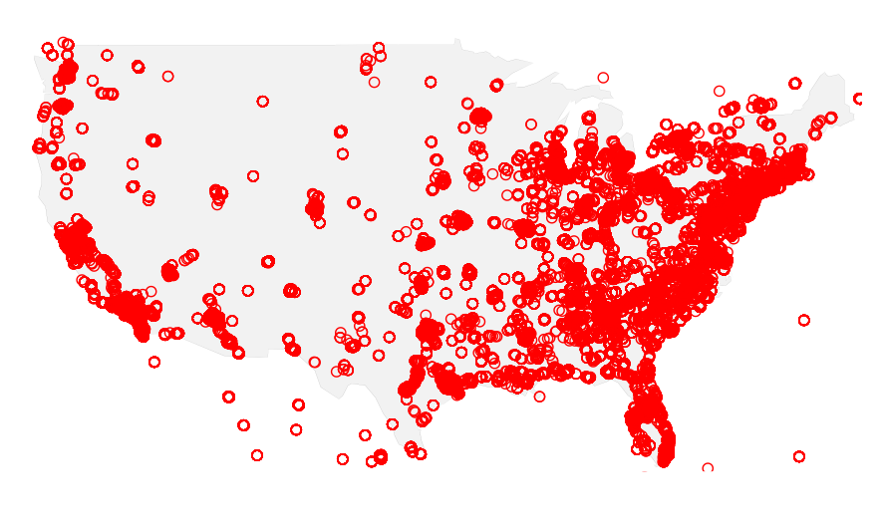

Part 2: Mapping coordinates to regions

As I was interested in regions, rather than precise geographic coordinates, I mapped the UTM coordinates to states, and then mapped states to regions. I did this in R, using the spatial points, maps, and maptools library. The following function, adapted from @rweald, will take in a dataframe of longitude and latitude columns, convert it to a spatial polygons object, grab the indices of the spatial polygons object, and match them to their state names.

library(sp)
library(maps)
library(maptools)
latlong2state <- function(pointsDF) {
states <- map('state', fill=TRUE, col = "transparent", plot=FALSE)
IDs <- sapply(strsplit(states$names, ":"), function(x) x[1])
states_sp <- map2SpatialPolygons(states, IDs=IDs, proj4string=CRS("+proj=longlat +datam=wgs84"))

#convert pointsDF to a SpatialPoints object
points_sp <- SpatialPoints(pointsDF, proj4string=CRS("+proj=longlat + datum=wgs84"))

# get indices of the Polygons object containing each point
indices <- over(points_sp, states_sp)

# get state names of the PO
stateNames <- sapply(states_sp@polygons, function(x) x@ID)
stateNames[indices]
}

#run latlong2state over data
states <- latlong2state(splitUTM_fixed)

I used some kind-of-quick and definitely-dirty regex to map the state names to the 10 regions. The following maps the states of New England:

states2reg <- gsub("maine|vermont|massachusetts|connecticut|new hampshire|rhode island", "New England", states)

Of course, I had to connect the regions back to the tweets, which I did by making the regions a data frame and binding it to the one containing the tweets and user IDs. That code and the above code correspond to the longlatregions_final.r script in GeoTwitter.

I got the number of tweets/region by summarizing values as factors. Here are the frequency counts for all the regions (I’m not sure what the blank column is, since it’s not NA’s):
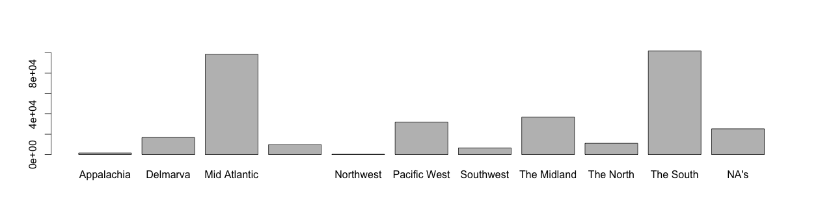
As you can see, the Mid Atlantic (98,579) and the South (101,818) contributed the most tweets. The Northwest only contributed 246 tweets. (Image at region_tweet_frequencies.png)

Frequencies obtained, I split the bound data into training data and test data, and saved each as a csv (short_clean_train.csv, short_clean_test.csv).

Part 3: Get the feature words

Initially, I'd wanted to bring in external regional word lists, but I ended up not doing this because a) such lists are neither free nor computer-readable, and b) using these word lists would answer the question: "Do people use traditional regional slang on Twitter?" but not necessarily the much broader and more flexible question of: "Do Twitter users exhibit geographic language patterns?"
Instead, I created word lists from the tweets in the training data. First, in R, I ran some regex over the tweets to get rid of @ mentions. (While the question of whether @ mentions have geographic patterns is interesting, it's not in the scope of this project.) I subset the cleaned data by region, and saved each subset as a csv (format: region.csv, eg mid_atlantic.csv). This code and data are stored in all2reg.r script in GeoTwitter.

To get the feature words from the regional csvs, I used the Count Vectorizer from python's scikit learn library. For each region's tweets, the Count Vectorizer grabbed the 100 most common words, excepting stop words like "and" and "the." I tried grabbing bigrams as well, but the phrases returned weren't useful. I saved the words to csv files (format: region_words.csv).

#load region data
filename = sys.argv[1]
train_data = pd.read_csv(filename)

#convert Tweet column to string for vectorizer
train_data.Tweet = str(train_data.Tweet)

from sklearn.feature_extraction.text import CountVectorizer

#make vectorizer
word_vectorizer = CountVectorizer (stop_words = 'english', token_pattern=r'\b\w+\b', max_features=100, min_df=1)

text_features2 = word_vectorizer.fit_transform(train_data.Tweet)

#get feature names
words = word_vectorizer.get_feature_names()

#save words to list
f = open(sys.argv[2], "w")
mylist = words
f.write("\n".join(map(lambda x: str(x), words)))
f.close()

The above code corresponds to the get_top_words.py script in GeoTwitter.

Here are some of the words for each region:

New England | Delmarva | Southwest | Mid Atlantic | South | Midland | Pacific West | Northwest
champ | bomb | addikted | bbm | cousin | abusive | bagel | broncos
feelin | broke | chicken | chillin | drinkin | bub | bieber | dammit
issues | curtains | drunks | disgusting | fee | deeburnz | frisk | eh
jayz | forgiven | free | girls | hiiii | god | ima | golden
sinuses | hoodies | itz | god | mite | jah | lilly | horse
swing | ima | kalled | lmao | peezly | lost | really | major
pt | joint | lockdown | pelfreys | sunday | luck | tryna | peanut
yanna | lord | rupaul | perm | tea | peaceful | tulo | roofying
zonin | packin | vegas | pissy | wheels | rejoice | wonderland | sho
wishes | taboo | woke | studio | yall | tryna | ya | wrench

Back to visualizing! I wanted to know about the words that regions shared in common--and words they did not. I used the Text Mining and ggplot2 packages in R to get the answers. As I was running out of time, I only visualized the word similarities for two regions: the Mid Atlantic and Appalachia. I figured these would be interesting to compare because, while they are fairly close geographically, historically, they have had distinct dialects.
I modified Drew Conway's Better Wordcloud script to make the wordclouds.
I created a corpus consisting of the two feature word sets, loaded it, and created a term frequency matrix.

my.path <- ('~/GeoTwitter/visualizations/')
library(tm)
my.corpus <- Corpus(DirSource(my.path), readerControl= list (reader=readPlain))
my_corpus.matrix <- TermDocumentMatrix(my.corpus)

Then I put that corpus into a data frame and added a column for term frequency differences between Appalachia and Mid atlantic

my_corpus.df <- as.data.frame(inspect(my_corpus.matrix))

#add column that displays term freq differences between appalachia and mid atlantic
my_corpus.df <- transform(my_corpus.df, freq.dif=mid_atlantic_words_viz.txt-appalachia_words_viz.txt)

I subset that data frame into three data frames--one for words said more often in Mid Atlantic, one for words said more often in Appalachia, and one for words said equally. I created a function to get the space between the three frequencies, and then added that space back into the three data frames.

optimal.spacing <- function(spaces) {
if(spaces>1) {
spacing<-1/spaces
if(spaces%%2 > 0) {
lim<-spacing*floor(spaces/2)
return(seq(-lim,lim,spacing))
}
else {
lim<-spacing*(spaces-1)
return(seq(-lim,lim,spacing*2))
}
}
else {
return(0)
}
}

#apply spacing function to frequencies
mid_atlantic.spacing <- sapply(table(mid_atlantic.df$freq.dif), function(x) optimal.spacing(x))
appalachia.spacing <- sapply(table(appalachia.df$freq.dif), function(x) optimal.spacing(x))
equal.spacing<-sapply(table(equal.df$freq.dif), function(x) optimal.spacing(x))

#now add that spacing back into dfs, where it will become the y column
mid_atlantic.optim <- rep(0, nrow(mid_atlantic.df))
for (n in names(mid_atlantic.spacing)) {
mid_atlantic.optim[which(mid_atlantic.df$freq.dif==as.numeric(n))] <- mid_atlantic.spacing[[n]]
}
mid_atlantic.df <- transform(mid_atlantic.df, Spacing=mid_atlantic.optim)

appalachia.optim <- rep(0, nrow(appalachia.df))
for (n in names(appalachia.spacing)) {
appalachia.optim[which(appalachia.df$freq.dif==as.numeric(n))] <- appalachia.spacing[[n]]
}
appalachia.df <- transform(appalachia.df, Spacing=appalachia.optim)

equal.df$Spacing <- as.vector(equal.spacing)

Then, to create the word cloud, I used ggplot, and set x as the frequency difference and y as the spacing.

optim[which(mid_atlantic.df$freq.dif==as.numeric(n))] <- mid_atlantic.spacing[[n]]
}
mid_atlantic.df <- transform(mid_atlantic.df, Spacing=mid_atlantic.optim)

appalachia.optim <- rep(0, nrow(appalachia.df))
for (n in names(appalachia.spacing)) {
appalachia.optim[which(appalachia.df$freq.dif==as.numeric(n))] <- appalachia.spacing[[n]]
}
appalachia.df <- transform(appalachia.df, Spacing=appalachia.optim)

equal.df$Spacing <- as.vector(equal.spacing)

#visualize!
mid_atlantic_vs_appalachia <- ggplot(mid_atlantic.df, aes(x=freq.dif, y=Spacing))+geom_text(aes(size=mid_atlantic_words_viz.txt, label=row.names(mid_atlantic.df), colour=freq.dif))+
geom_text(data=appalachia.df, aes(x=freq.dif, y=Spacing, label=row.names(appalachia.df), size=appalachia_words_viz.txt, color=freq.dif))+
geom_text(data=equal.df, aes(x=freq.dif, y=Spacing, label=row.names(equal.df), size=mid_atlantic_words_viz.txt, color=freq.dif))+
scale_size(range=c(3,11), name="Word Frequency")+scale_colour_gradient(low="darkred", high="darkblue", guide="none")+
scale_x_continuous(breaks=c(min(appalachia.df$freq.dif),0,max(mid_atlantic.df$freq.dif)),labels=c("Said More in Appalachia","Said Equally","Said More in Mid Atlantic"))+
scale_y_continuous(breaks=c(0),labels=c(""))+xlab("")+ylab("")+theme_bw(base_family= 'Helvetica')
ggsave(plot=mid_atlantic_vs_appalachia,filename="ma_app.png",width=13,height=7)

Which resulted, alas in this:

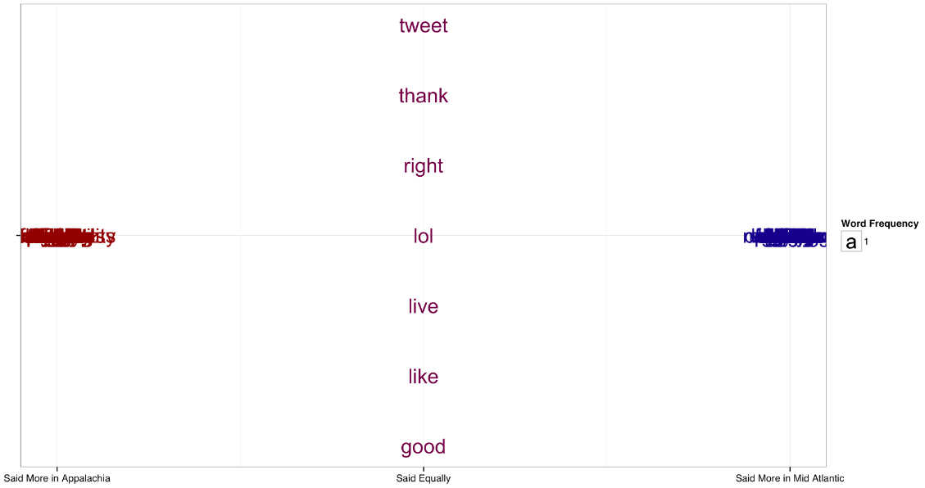

As you can see, the unique words are layered atop each other.
The above code corresponds to the compare_words_wordcloud.r script; the image corresponds to ma_app.png in GeoTwitter.

Part 4: Counting feature words

So now I had my feature words and I had my tweets, and I wanted to know whether the presence and quantity of feature words in a given tweet was a decent predictor of the tweeter's home region.
In python, I built feature word counters for each region, using Mueller's BadWordsCounter from Kaggle's insult contest as a guide. For a given document (in my case, the training tweets), the counter runs through each tweet and counts the feature words per word in the tweet, then stores the sum of the words/tweet in a second list.

class NEWordCounter(BaseEstimator):
#open North words list
def __init__(self):
with open("ne_words.csv") as f:
ne_words = [l.strip() for l in f.readlines()]
self.ne_words_ = ne_words

def transform(self, documents):
list = []
for c in documents:
sum_list = []

for w in self.ne_words_:
#print w, " occurs ", str(c).lower().count(w), "times in ", str(c)
numOccur = [np.sum(str(c).lower().count(w))]
if (numOccur == None):
numOccur = []

print sum_list.append(numOccur)
list.append([np.sum(sum_list)])

print "Here's the List: ", list
return list
That code is stored in the reg_words_check.py script in GeoTwitter.

Still in python, I ran the feature word counters through the training and test tweets, and saved the count lists to csv files (format: region_wordcount.csv). I only got through the counters for New England and Appalachia. This code is stored in the region_words_data.py script in GeoTwitter.

I had wanted to join the word counts arrays to the training and test data in python, but errors and desire to see my data in tidy excel-like tables eventually steered me over to R. I loaded in the training and count csvs and bound them with column-bind. I used grepl to create new boolean columns for presence of region.Then, I was finally ready to predict!
I wanted to use glm in R, because I was predicting on a categorical variable, rather than a numeric one.

Part 5: Modeling and predicting on feature words

After all that prepping, the actual modeling was pretty easy. I'm guessing that's usually the case, in life as in machine learning. I split my training data into a train set and a test set with a 10:1 train data: test data ratio.

set.seed(43)
train_words_numbers$fold <- sample(1:10, nrow(train_words_numbers), replace=TRUE)
train <- subset(train_words_numbers, fold != 3)
test <- subset(train_words_numbers, fold == 3)

As mentioned, I wanted to know if the number of a region's feature words in a given tweet could accurately predict the home location of that user. I used linear regression to model this:
model_glm <- glm(Is_New_England ~ New.England.Words, data = train, family='binomial')
Where New.England.Words was the number of New England words in a given tweet and New_England was the boolean is/is not New England column.

I put the model to my test set:
test.predict <- predict(model_glm, test, type="response")

And evaluated the performance of those predictions using R's ROCR library. I wanted to know what percent of classifications were correct and the area under the curve.
library('ROCR')
pred <- prediction(test.predict, test$Is_New_England)
perf <- performance(pred, measure='acc')
plot (perf)
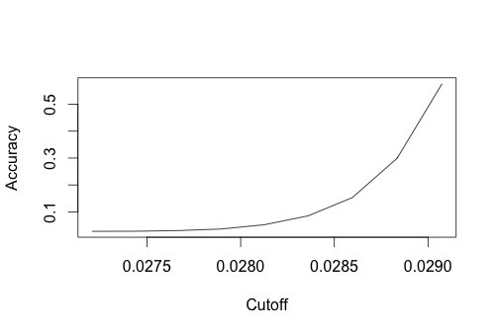
perf_auc <- performance(pred, measure='auc')

Sadly, the accuracy score for New England was only very slightly above 50%.

My final linear regression model was trained on the full training set.

model_glm_final <- glm(Is_New_England ~ New.England.Words, data = train_words)
predictions <- predict(model_glm_final, test_words, type="response")

The above code corresponds to the reg_predict_glm.r script in GeoTwitter.

Looking at the summary of predictions, which ranges from 2.7% to 2.9%, with a median of 2.87%, I can say that my New England words are poor predictors of New Englandness. .

Part 6: Conclusion and real-world implementation

I can't say yet whether feature words can be used to predict Twitter location. I only managed to predict on one region, and it’s a transient, urban region, one whose inhabitants haven’t shared a distinct, singular dialect in decades. I would like to say, given the visual exploration and feature word extraction, for certain regions, the most distinct ones can be useful--ie "aye" and "hogie" in Appalachia, "bbm" and "prolly" in the Mid Atlantic, "watz" and "kalled" in the southwest, and, of course, the division between "lord" (South, Delmarva), and "god" (Mid Atlantic, The Midland).
Given more time, I would definitely want to try NLTK, which would offer much more robust tokenization--mine kept catching feature words in other words.
This research also pointed to the potential of topics as regional identifiers. I didn't intentionally dig into these, but I noticed that Appalachians tweeted about cooking, Southerners tweeted about guns, Northwesterners tweeted about horses and the Broncos, and Mid-Atlantic and Midlanders tweeted about sex.
I'm sorry to say that everyone tweeted about Justin Bieber.

At present, only 1% of tweets are geotagged; a reliable, reasonably accurate way to predict geographic ties would be very useful to everyone from marketers and advertisers looking to locally target users to law enforcement agencies trying to identify users. Of course, regions are much broader than states, or better yet, cities, but if this method is effective in a broad sense, it could be scaled down, given availability of training data.

Ideally, this code (post-counter fix) would run client-side. I would want to clean up the scripts and make sure everything in them was able to be replicated before releasing it to the wild. I suppose it could serve as the source of a web-based client, where users could call the Twitter API, pull in tweets, and then see the visualized results of the code's analysis.

Privacy is something I'd have to hammer out, though. In an academic setting, I like connecting dots, but in a real world setting, that may cause harm to users (see: Target's pregnant-teen reveal).

